Name : Atharva Mendhule
PRN : 25070521137
7.1.2] Possible Combinations from three Digits
Step 1: Start

Step 2: Read three space-separated digits a, b, and c

Step 3: Store the digits as strings

Step 4: Print a + b + c Step 5: Print a + c + b Step 6: Print b + a + c Step 7: Print b + c + a Step 8: Print c + a + b Step G: Print c + b + a Step 10: Stop
- PYTHON CODE
a, b, c = input().split()

print(a + b + c) print(a + c + b) print(b + a + c) print(b + c + a) print(c + a + b) print(c + b + a)

- FLOWCHART

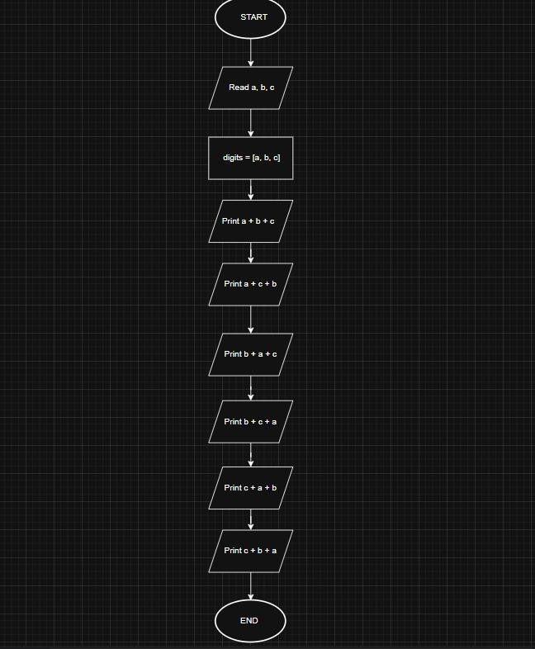

- EXCECUTION

